**Customer Segmentation Analysis Report**

* 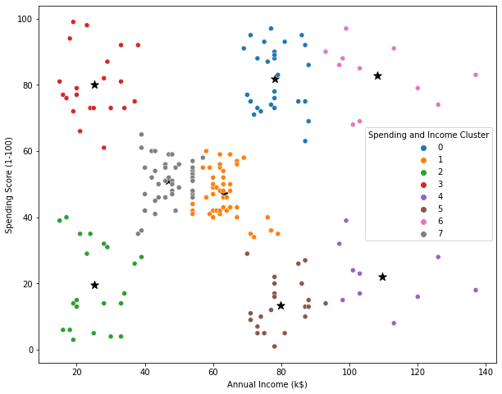Target Group would be the cluster 1, which has a high Spending score and high

Income.

* 54 percent of cluster 1 shoppers are women. We should look for ways to attract these customers using a marketing campaign targeting popular items in this cluster.
* Cluster 2 presents an interesting opportunity to market to the customers for sales event on popular items.